

Translate True Copy
Bismillahir Rahmanir Rahim
Union Parishad Form No-7

07 No. Char Ramiz Union Parishad
Upazila: Ramgati, District: Lakshmipur.

Occupation & Trade License
Serial No: 467 Date: 01/08/2026
Name of Organization: SULTANA NASRIN BRICKS
License Holder's Name: SULTANA NASRIN
Father/Husband's Name: Siddikur Rahman
Address: Char Afzal
Place of Business: Chowmohoni Bazar
Type of Business: It-Vatta (Brick Kiln)
The licensee SULTANA NASRIN has paid the license fee of 500.00/-. This license is issued for one year for this Union from July 25 to June 26.
Amount of Paid Fees:
Current: | 500/-
Arrears: | -
VAT: | 75/-
Total: | 575/-
In Words: | Five Hundred Seventy-Five only.

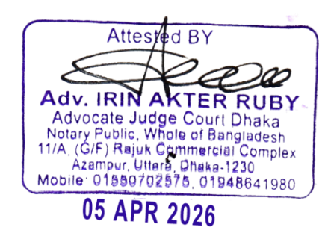
[Sd/- Illegible]  Administrative Officer  07 No. Char Ramiz Union Parishad  Ramgati, Lakshmipur. | [Sd/- Illegible]  01/04/26  Chairmen  07 No. Char Ramiz Union Parishad  Ramgati, Lakshmipur.

